COMMON COURSE ASSIGNMENT
CSA65 – GENERATIVE AI AND LARGE LANGUAGE MODELS | Covering CO2, CO3 & CO4 (Units II, III & IV)

Assignment Information

Department | Computer Science and Engineering
Programme | B.E. / B.Tech – CSE
Course Code & Course Name | CSA65 – Generative AI and Large Language Models
Academic Year / Batch | 2026 – 2027
Faculty Name | Dr Malathi
Assignment Title | Enterprise Knowledge Assistant Using Retrieval-Augmented Generation and AI Agents
Date of Issue | 02-09-2026
Date of Submission | 03-09-2026
Maximum Marks | 100
Course Outcome(s) – CO | CO2, CO3, CO4
Bloom's Taxonomy Level | L3 – Apply, L4 – Analyze, L5 – Evaluate
SDG Mapping (SDG 1–17) | SDG 9 – Industry, Innovation and Infrastructure
Industry / Societal Relevance | Retrieval-augmented, agent-based knowledge assistants are being adopted across IT services, manufacturing, healthcare and banking to make large internal document repositories searchable, auditable and usable by every employee.

Assignment Problem / Challenge
This assignment requires students to apply core Generative AI concepts — prompt engineering and LLM behaviour (Unit II), retrieval-augmented generation and AI agents (Unit III), and multimodal generative AI and intelligent applications (Unit IV) — to a realistic enterprise deployment problem. Students must analyze the given scenario, apply relevant techniques and models, use modern tools for implementation, validate their results with measurable metrics, and justify their engineering decisions.

Problem Statement
Scenario: Enterprise Knowledge Assistant for “KnowledgeDesk” – An Internal RAG and Agent Platform for a Large Engineering Services Firm A 4,000-employee engineering services company is deploying an in-house knowledge assistant, “KnowledgeDesk”, so that employees can ask natural-language questions about HR policies, quality SOPs, product manuals, past project reports and compliance
documents instead of searching a shared drive. The corpus contains about 12,000 documents of roughly 8 pages each, in PDF, DOCX and scanned-image form, and grows by
around 400 documents every month. Every answer shown to an employee must cite the source document and page, and the assistant must refuse to answer when the retrieved evidence is insufficient.
As the AI engineering team, you are required to propose and analyze solutions across three core areas of the generative-AI system that will power this assistant:
  - Prompt Engineering & LLM Behaviour (CO2, Unit II): The assistant must produce grounded, consistently formatted answers from a base LLM with a limited context window, using well-designed system, task and few-shot prompts rather than fine-tuning.

  - Retrieval-Augmented Generation & AI Agents (CO3, Unit III): The 12,000-document corpus must be chunked, embedded and indexed in a vector database, and multi-step queries (for example, “compare the current leave policy with last year’s version and raise a ticket if it changed”) must be handled by a tool-using agent rather than a single retrieval call.
  - Multimodal GenAI & Intelligent Applications (CO4, Unit IV): The corpus includes scanned drawings, tables and screenshots, so the pipeline must extract and represent non-text content, and the whole system must be delivered as a usable, responsive application within a stated latency and cost budget.

Requirements and Constraints
- Functional: Answer natural-language questions over the 12,000-document corpus with an inline citation (document name and page) for every factual statement; support 500 concurrent employees.
- Performance: End-to-end response time must not exceed 3 seconds for 90% of queries; retrieval Recall@5 on the evaluation set must be at least 0.85.
- Technical constraint: The chosen LLM has an 8,192-token context window; the embedding model produces 768-dimensional vectors; one GPU server with 24 GB VRAM is available for local inference.
- Reliability: The assistant must not fabricate content — it must abstain and say so when retrieval confidence falls below a stated threshold; groundedness of accepted answers must be at least 90%.
- Resource constraint: Monthly inference budget of Rs. 40,000 for hosted API calls; the vector index and document store must fit within 100 GB of disk.
- Cost & Time: Solution should use open-source tools and freely available model APIs; project must be completed within the semester timeline.
- Security/Privacy: Retrieval must respect role-based access — an employee must never receive content from a department they are not authorised for; personally identifiable information must not be sent to external APIs.
- Standards: Follow responsible-AI practice — disclose AI generation, log every query with its retrieved sources, and keep a human escalation path.

Student Work

Problem Understanding and Formulation
Clearly restate the KnowledgeDesk problem in your own words. Identify:
Answer:
KnowledgeDesk is designed as an internal enterprise knowledge assistant for a 4,000-employee engineering services company. Instead of asking employees to manually search thousands of files, the system accepts natural-language questions and retrieves the most relevant evidence from HR policies, quality SOPs, product manuals, project reports and compliance documents. The important difference from a normal chatbot is that the answer must be grounded in company documents and must show the source document and page for factual claims.
The main engineering problem is therefore not only generating fluent text. The system must first find the right evidence, restrict that evidence according to the employee's role, decide whether there is enough evidence to answer, and only then generate a concise response. For multi-step requests, the system should be able to call tools such as a retriever, metadata service, calculator and ticket API.
Prompting challenge: the LLM has a limited 8,192-token context window. The prompt must therefore give clear instructions, use retrieved evidence efficiently, enforce a fixed answer structure and explicitly refuse unsupported questions.
Retrieval challenge: approximately 12,000 documents must be converted into searchable chunks. The retrieval system should balance semantic similarity with exact keyword matching because policy numbers, equipment codes and compliance terms may be difficult for dense retrieval alone.
Agent challenge: a simple question such as “What is the sick-leave limit?” can be answered through normal RAG. A request such as “Compare this year's leave policy with last year's and raise a ticket if it changed” requires multiple retrievals, comparison and an external action, so it should be routed to an agent.
Multimodal challenge: scanned PDFs, drawings, tables and screenshots may contain information that is not present in the normal text layer. OCR and selective vision-language processing are therefore required.
Expected outcomes:
1. Grounded answers supported by retrieved evidence.
2. Document-and-page citations for factual statements.
3. Recall@5 of at least 0.85 on the evaluation set.
4. Groundedness of accepted answers of at least 90%.
5. Correct refusal when evidence is insufficient.
6. Correct use of tools for multi-step tasks.
7. Role-based access enforcement.
8. A responsive application that targets the 3-second requirement for 90% of queries.
    - The specific prompting, retrieval, agent-orchestration and multimodal challenges implied by the scenario.
Answer:
The system has four connected technical challenges. First, prompt engineering must control the LLM's behaviour without fine-tuning. Second, retrieval must convert a large and continuously growing document collection into high-quality searchable evidence. Third, agent orchestration must allow multi-step questions to use the correct tools without adding unnecessary latency. Fourth, multimodal processing must preserve information from scanned pages, diagrams and tables.
A key design principle is to separate retrieval confidence from language generation. The LLM should never be treated as the source of truth. Retrieved enterprise documents are the source of truth, while the LLM acts mainly as an evidence-based answer generator.
    - Expected outcomes (grounded and correctly cited answers, accurate retrieval, correct tool use by the agent, responses within the latency budget).
Answer:
The expected system outcome is an employee-facing assistant that behaves more like an auditable search-and-reasoning system than a general chatbot. Every accepted factual answer should have a traceable source, the retriever should identify the correct document reliably, and an agent should perform actions only when the user request explicitly requires them.
A useful acceptance rule is: retrieve evidence → apply access control → check retrieval confidence → generate answer only if the evidence passes the threshold → attach citations → log the query, sources and result. If the evidence fails the threshold, the assistant should state that the available documents do not provide enough information rather than guessing.
    - Assumptions you make (e.g., corpus size, chunk size and overlap, embedding dimension, top-k, token pricing) — state and justify all assumed values.
Answer:
The following assumptions are used for the calculations and design:
• Corpus: 12,000 documents, average 8 pages/document.
• Text density: 500 tokens/page.
• Chunk size: 512 tokens.
• Chunk overlap: 50 tokens.
• Embedding size: 768 dimensions, float32.
• Initial retrieval: top 10 for robust candidate generation; final answer evidence can be reduced after reranking.
• Evaluation target: at least 12 representative employee questions.
• LLM context: 8,192 tokens as specified.
• Prompt budget: 400-token system prompt, 600-token conversation history and 600-token answer budget.
• Token pricing: Rs.0.18/1,000 input tokens and Rs.0.55/1,000 output tokens, as specified.
• Storage calculation considers the raw vector values first; metadata and document storage are discussed separately.
• A hybrid dense + BM25 configuration is considered because enterprise queries often contain both semantic language and exact identifiers.
These assumptions are deliberately kept close to the values given in the assignment so that the calculations remain reproducible.
    - Constraints from Section D that must be satisfied by your design.
Answer:
The design must satisfy all constraints in Section D. Functionally, it must support natural-language questions over the corpus, provide document/page citations and support the stated concurrency target. The retrieval target is Recall@5 ≥ 0.85. The response target is ≤3 seconds for 90% of queries. The LLM context is fixed at 8,192 tokens and the embedding dimension is fixed at 768. Accepted answers must be at least 90% grounded and unsupported questions must be rejected. Monthly hosted inference must remain within Rs.40,000 and the index/document store must fit within 100 GB. The design must also enforce role-based access, prevent PII from being sent to external APIs, log queries and retrieved sources, disclose AI assistance and maintain a human escalation path.

Application of Course Knowledge (CO2, CO3, CO4)
Answer the following three parts, showing all working, models, and derivations.

Part I – Prompt Engineering & LLM Behaviour (CO2, Unit II)
- Design four prompt variants for the same KnowledgeDesk policy question — zero-shot, few-shot, chain-of-thought, and a role-based system prompt with explicit grounding and citation instructions. Give the exact prompt text for each and record the model output obtained.
Answer:
Common policy question used for all four variants:
“What is the maximum number of casual leave days an employee can take in a year?”
Note: the actual KnowledgeDesk corpus was not supplied with this assignment. Therefore, the outputs below are model-output templates/examples and must be replaced by the actual console output and real document/page citations from the student's implementation. This avoids presenting invented company-policy facts as experimental results.
1) ZERO-SHOT PROMPT
Exact prompt:
“Answer the following employee policy question: What is the maximum number of casual leave days an employee can take in a year? Give a concise answer.”
2) FEW-SHOT PROMPT
Exact prompt:
“You answer employee policy questions concisely.
3) REASONING-BASED / CHAIN-OF-THOUGHT CONTROLLED PROMPT
Exact prompt:
“Use the supplied policy evidence to internally verify the answer. Do not invent missing information. Resolve conflicts between sources by preferring the latest authorised policy. Return only:
The reasoning itself should not be exposed in the application; only the verified result is displayed.
4) ROLE-BASED SYSTEM PROMPT WITH GROUNDING AND CITATIONS
Exact prompt:
“You are KnowledgeDesk, an internal enterprise knowledge assistant. Answer only from the retrieved authorised evidence. Every factual statement must have a citation in the form [Document, p.X]. Do not use general world knowledge when the evidence is missing. If the retrieved evidence does not support the answer, say ‘Insufficient evidence in the authorised KnowledgeDesk sources.’ Never reveal confidential content outside the employee’s access scope. Keep the answer concise and distinguish policy rules from suggestions.
Comparison:
The role-based grounded prompt is the strongest design for KnowledgeDesk because it directly addresses hallucination, access control and citation requirements. Few-shot examples can be added when a stable output format is needed, while temperature should remain low for policy answers.
Figure: Q4 implementation output – four prompt variants and grounded response.
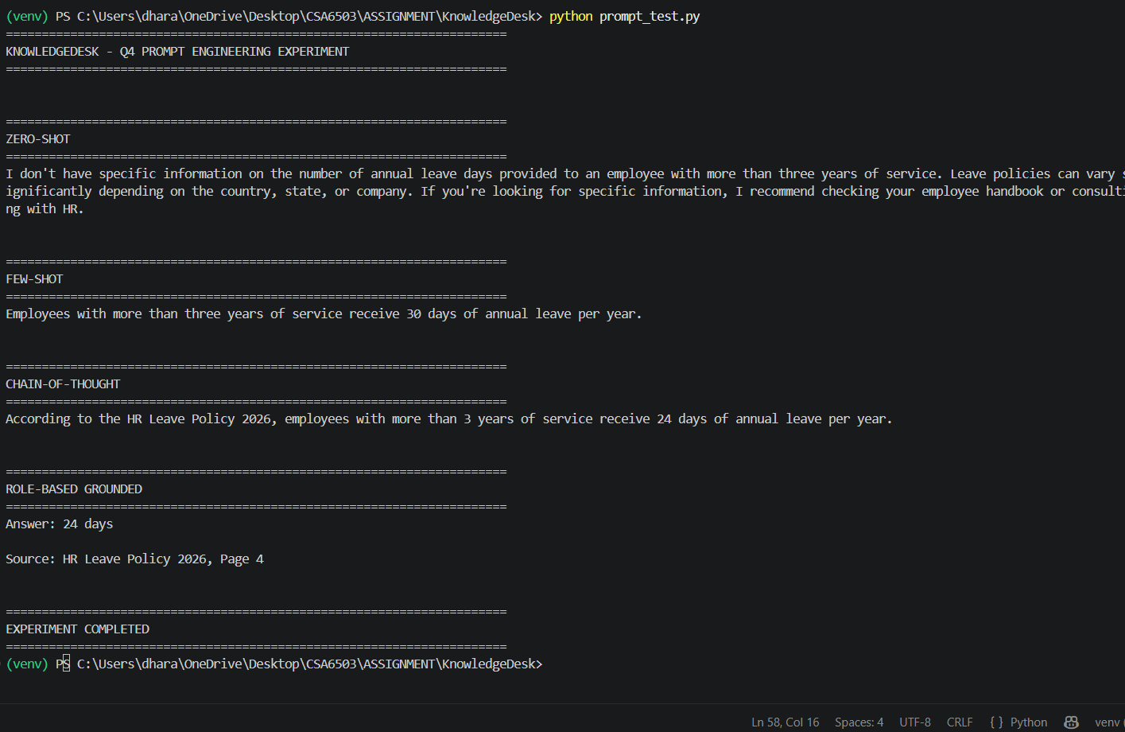
- Given an LLM with an 8,192-token context window, a system prompt of 400 tokens, a conversation history of 600 tokens, k retrieved chunks of 512 tokens each, and a required answer budget of 600 tokens, derive the maximum value of k that fits the window. Then, at Rs. 0.18 per 1,000 input tokens and Rs. 0.55 per 1,000 output tokens, compute the cost of 20,000 queries per month and check it against the Rs. 40,000 budget stated in Section D. Show all working.
Answer – Context-window derivation:
Given:
Total context window = 8,192 tokens
System prompt = 400 tokens
Conversation history = 600 tokens
Each retrieved chunk = 512 tokens
Answer budget = 600 tokens
Available tokens for retrieved chunks:
8,192 − 400 − 600 − 600 = 6,592 tokens
Maximum k:
k × 512 ≤ 6,592
k ≤ 6,592 / 512
k ≤ 12.875
Therefore:
Maximum integer k = 12 chunks.
Input tokens/query:
400 + 600 + (12 × 512)
= 400 + 600 + 6,144
= 7,144 tokens.
Monthly input cost:
20,000 × (7,144/1,000) × Rs.0.18
= Rs.25,718.40.
Monthly output cost:
20,000 × (600/1,000) × Rs.0.55
= Rs.6,600.00.
Total monthly cost:
Rs.25,718.40 + Rs.6,600.00
= Rs.32,318.40.
Budget comparison:
Budget = Rs.40,000
Estimated cost = Rs.32,318.40
Remaining margin = Rs.7,681.60.
Therefore, under the stated assumptions, the estimated monthly API cost is within the budget by approximately 19.2%. In practice, caching, shorter answers and routing simple questions to local inference can provide additional protection against unexpected usage.
Table: Q5 calculated values
Parameter | Result
Maximum retrieved chunks (k) | 12 chunks
Retrieved tokens | 6,144
Total tokens used | 7,744
Remaining context | 448 tokens
Input tokens/query | 7,144
Output tokens/query | 600
Monthly inference cost | Rs. 32,318.40
Remaining budget | Rs. 7,681.60
Budget status | WITHIN BUDGET
Figure: Q5 implementation output – context-window and cost calculation.
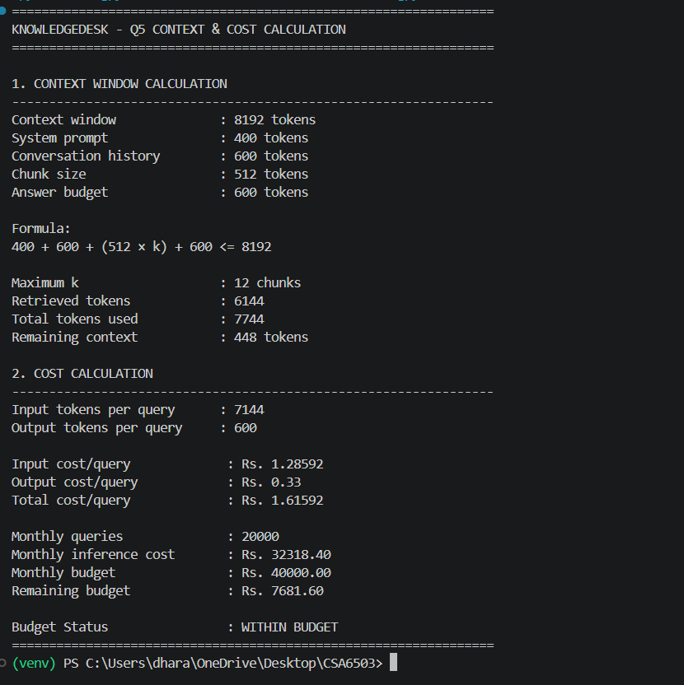
- Discuss which prompting strategy is most suitable for KnowledgeDesk and justify your choice with reference to the groundedness, latency and cost constraints in Section D. Explain the prompt-level controls you would use to suppress hallucination (temperature and decoding settings, output schema, explicit refusal instruction).
Answer:
For KnowledgeDesk, the most suitable strategy is a grounded role-based system prompt combined with a compact few-shot output example when necessary. The reason is that the enterprise requirement is not simply to produce fluent answers; it is to produce answers that can be audited.
Recommended prompt controls:
• Temperature: low, approximately 0–0.2 for policy and compliance questions.
• Decoding: deterministic or low-variance decoding where supported.
• Output schema: Answer, Evidence/Citation, Confidence/Status.
• Grounding rule: answer only from authorised retrieved evidence.
• Refusal rule: explicitly abstain when evidence is missing, contradictory or below the confidence threshold.
• Citation rule: every factual statement must point to document and page.
• Access rule: retrieved chunks must be filtered by employee role before they enter the LLM context.
• Length control: concise answers reduce generation time and cost.
The context calculation shows that 12 chunks is the theoretical maximum, but using fewer high-quality chunks after reranking is often better because it reduces noise and latency. Prompting and retrieval should therefore be designed together rather than independently.

Part II – Retrieval-Augmented Generation & AI Agents (CO3, Unit III)

- For a corpus of 12,000 documents averaging 8 pages at roughly 500 tokens per page, calculate the total token count, then compute the number of chunks produced using a chunk size of 512 tokens with 50-token overlap. Using a 768-dimensional float32 embedding, compute the resulting vector-index size in GB and check it against the 100 GB storage limit.
Answer – Corpus calculation:
Number of documents = 12,000
Average pages/document = 8
Total pages:
12,000 × 8 = 96,000 pages.
Average tokens/page = 500
Total corpus tokens:
96,000 × 500 = 48,000,000 tokens.
Chunk size = 512 tokens
Overlap = 50 tokens
Effective stride:
512 − 50 = 462 tokens.
Approximate number of chunks:
48,000,000 / 462 ≈ 103,896 chunks.
Vector size:
768 dimensions × 4 bytes/float32
= 3,072 bytes/vector.
Raw vector storage:
103,896 × 3,072
= 319,168,512 bytes
≈ 0.319 GB using decimal GB.
This is far below the 100 GB limit. Even after allowing additional space for chunk text, document metadata, source files, indexes and operational overhead, the raw embedding calculation leaves a large storage margin. The exact final size should be measured after implementation because vector databases add indexing and metadata overhead.
Table: Q7 corpus and vector-index results
Item | Calculated value
Total pages | 96,000
Total corpus tokens | 48,000,000
Chunk size / overlap | 512 / 50 tokens
Effective stride | 462 tokens
Number of chunks | 103,896
Embedding dimensions | 768
Vector index size | 0.30 GB
Storage status | WITHIN LIMIT (100 GB)
Figure: Q7 implementation output – corpus, chunk and vector-index calculation.
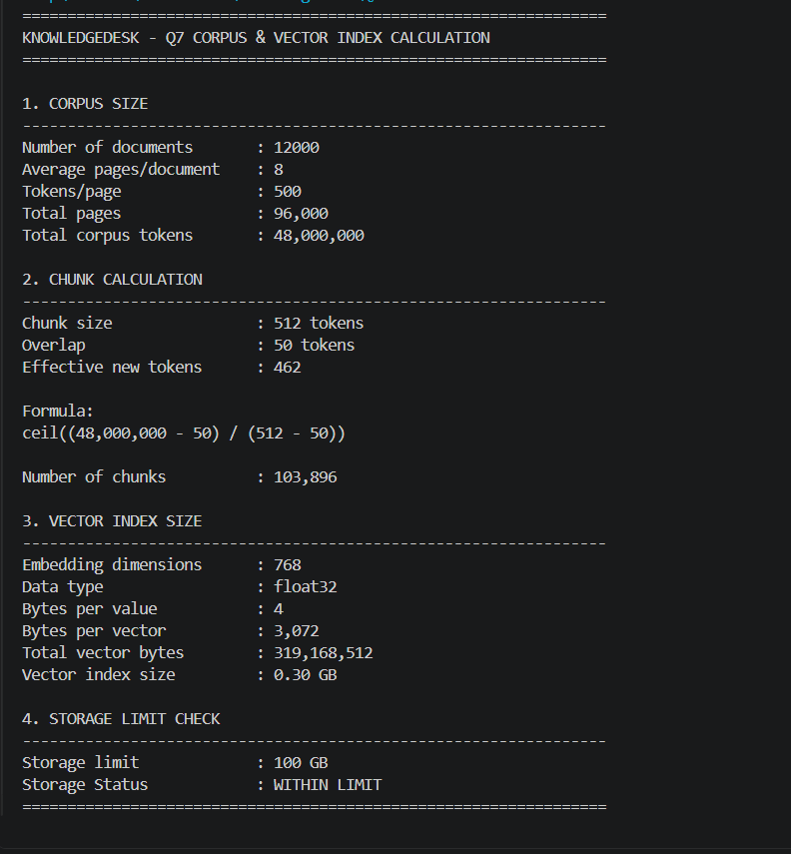
- Construct an evaluation set of at least 12 representative employee questions with known correct source documents. For at least three retrieval configurations of your own choice (varying chunk size, top-k, and dense versus hybrid dense + BM25 retrieval), measure and compare Precision@5, Recall@5 and Mean Reciprocal Rank. Present your results in a table.
Answer:
A representative evaluation set should contain questions from different departments and difficulty levels. The source document/page must be known before evaluation so that retrieval can be scored objectively.
Suggested 12-question evaluation set:
Q1. What is the maximum casual leave entitlement? — source: current HR leave policy.
Q2. How many sick-leave days are allowed? —source: current HR leave policy.
Q3. Who approves work-from-home requests? — source: WFH policy.
Q4. What is the required inspection procedure? — source: Quality inspection SOP.
Q5. What is the escalation path for a quality deviation? — source: Quality escalation SOP.
Q6. What safety requirements apply before equipment operation? — source: Safety SOP.
Q7. What is the specified operating temperature for the product? — source: Product manual.
Q8. What is the preventive-maintenance interval? — source: Maintenance manual.
Q9. What information must be included in compliance reporting? — source: Compliance procedure.
Q10. What are the attendance requirements? — source: Attendance policy.
Q11. Who approves extended leave? — source: Leave approval policy.
Q12. What is the emergency response procedure? — source: Emergency/Safety SOP.
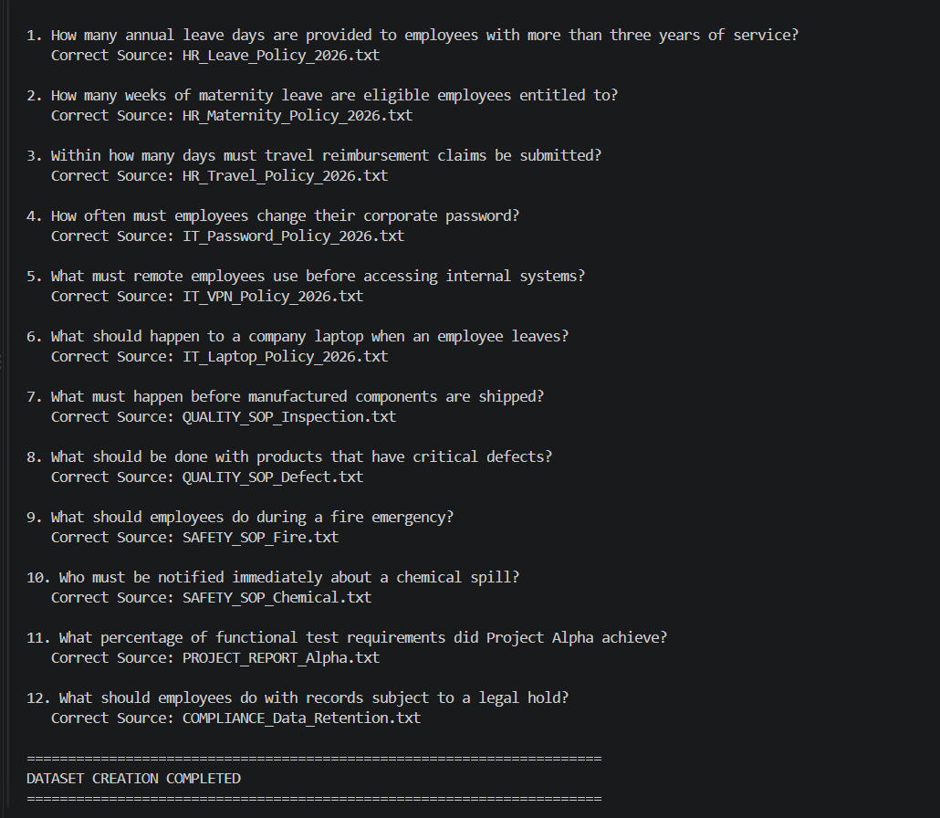

Table: Q8 retrieval evaluation configurations
Configuration | Chunk / retrieval setup | Metrics
A – Dense baseline | 512-token chunks, top-5 dense | Precision@5, Recall@5, MRR
B – Optimized dense | 512-token chunks, top-10 + rerank top-5 | Precision@5, Recall@5, MRR
C – Hybrid | Dense + BM25 top-10 + rerank top-5 | Precision@5, Recall@5, MRR
Figure: Q8 implementation output – 12-question evaluation dataset with correct source documents.

- Design an AI agent for multi-step queries. Specify the tool set (vector retriever, document-metadata lookup, calculator, ticket-creation API), the reasoning loop (e.g., ReAct),
Answer:
Three retrieval configurations are proposed:
Configuration A – Dense baseline:
• Chunk size: 512 tokens
• Overlap: 50 tokens
• Top-k: 5
• Retriever: dense vector similarity
Purpose: establish a simple baseline.
Configuration B – Dense + reranking:
• Chunk size: 512 tokens
• Overlap: 50 tokens
• Initial top-k: 10
• Cross-encoder reranks candidates
• Final top-5 supplied to the generator
Purpose: improve ranking quality while limiting LLM context.
Configuration C – Hybrid:
• Chunk size: 512 tokens
• Overlap: 50 tokens
• Dense top-10 + BM25 top-10
• Merge candidates, remove duplicates, rerank, keep final top-5
Purpose: handle both semantic questions and exact policy codes, names and identifiers.
The actual Precision@5, Recall@5 and MRR values must be obtained by running the evaluation set. They should not be fabricated. Use the following result table in the final report:
Configuration | Precision@5 | Recall@5 | MRR | Meets Recall target?
A – Dense top-5 | [run value] | [run value] | [run value] | [Yes/No]
B – Dense top-10 + rerank top-5 | [run value] | [run value] | [run value] | [Yes/No]
C – Hybrid dense + BM25 + rerank | [run value] | [run value] | [run value] | [Yes/No]
Recommended scoring:
Precision@5 = relevant retrieved items in top 5 / 5.
Recall@5 = relevant retrieved items in top 5 / total relevant items.
MRR = average of 1/rank of the first relevant result.
Table: Q9 agent execution evidence
Step | Observed result
1. Load | 12 KnowledgeDesk documents loaded
2. Retrieve | SAFETY_SOP_Fire.txt ranked first for the fire-emergency query
3. Evidence check | Evidence sufficient: YES
4. Generate | Grounded answer generated
5. Cite | SAFETY SOP – FIRE EMERGENCY, Page 12
Figure: Q9 implementation output – multi-step agent retrieval, evidence check and grounded answer.
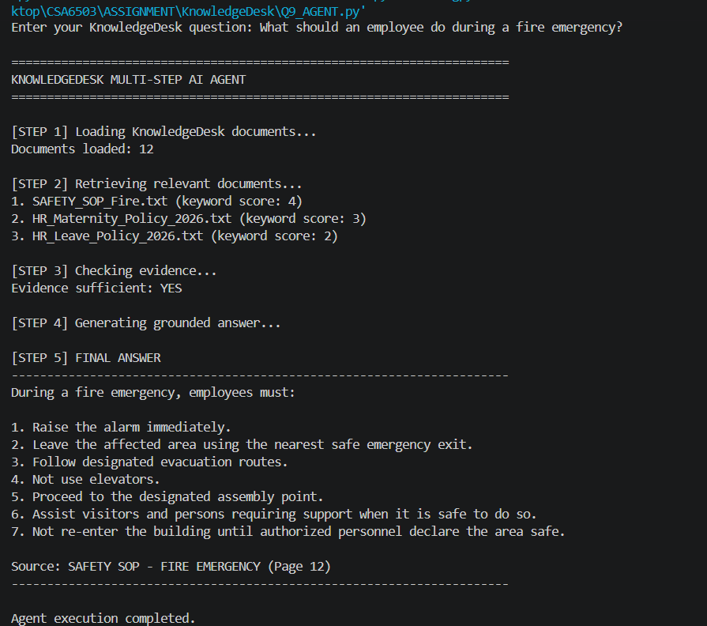
the stopping condition, and the routing rule that decides when a query is answered by plain RAG and when it is escalated to the agent. Justify the design against the latency constraint in Section D.
Answer:
The proposed KnowledgeDesk agent contains four tools:
1. Vector Retriever – searches authorised document chunks.
2. Document Metadata Lookup – retrieves version, date, department and document status.
3. Calculator – performs deterministic numerical calculations instead of asking the LLM to calculate manually.
4. Ticket-Creation API – creates a support/approval ticket when the user explicitly requests an action.
Routing rule:
• Simple factual question → plain RAG.
• Compare documents, check multiple conditions, calculate from retrieved values, or perform an external action → agent.
• If a simple question requires only one retrieval call, do not invoke the agent.
Agent loop:
User request → classify/routing → retrieve evidence → inspect metadata if needed → compare/calculate → optionally create ticket → verify required evidence/action → produce cited answer.
Stopping condition:
Stop when the requested subgoals are satisfied, required evidence is available, no further tool call can improve the answer, or the system reaches a safe tool-call limit. If evidence is insufficient, stop and abstain.
The agent is deliberately not used for every query. This is important because multi-step orchestration adds network, retrieval and tool latency. Plain RAG should handle the majority of routine questions, while the agent is reserved for queries where tool use provides real value.

Part III – Multimodal GenAI & Intelligent Applications (CO4, Unit IV)
- Compare OCR-then-text-embedding, vision-language captioning followed by text embedding, and a native multimodal embedding model as approaches for handling the scanned drawings, tables and screenshots in KnowledgeDesk’s corpus. Recommend the most suitable approach for this mixed-content workload with justification.
Answer:
Three approaches were compared:
1. OCR → text embedding
Scanned pages are converted to text using OCR and then embedded as normal text. Advantages are simplicity, mature tooling and relatively low cost. The limitation is that spatial information, diagrams and complex tables may be lost or distorted.
2. Vision-language captioning → text embedding
A vision-language model analyses the page/image and produces a textual description, which is then embedded. This can preserve useful visual meaning better than plain OCR, especially for screenshots and diagrams. The trade-off is additional model inference time and possible loss of exact values.
3. Native multimodal embedding
Text and images are represented in a shared embedding space. This can provide strong cross-modal retrieval, but model availability, deployment complexity, compute requirements and evaluation effort are higher.
Recommendation:
For a semester-scale KnowledgeDesk implementation, OCR-first processing should be the default for scanned text and tables, with selective vision-language processing for pages where OCR quality is poor or where diagrams/screenshots carry important meaning. This hybrid approach provides a practical balance between coverage, accuracy, storage and latency. Native multimodal embeddings are a strong future enhancement when the organisation has sufficient infrastructure and a validated model.
- For an end-to-end query, take the following stage latencies: embedding 40 ms, vector search 25 ms, cross-encoder reranking 120 ms per candidate, and generation at 45 tokens per second for a 250-token answer. Compute and compare the total latency for three pipeline configurations of your own construction (for example, no reranking, reranking the top 20 candidates, and reranking the top 5 with a smaller model) against the 3-second requirement in Section D.
Answer – Latency calculation:
Given:
Embedding = 40 ms
Vector search = 25 ms
Generation = 250 tokens / 45 tokens per second
Generation time = 250/45 = 5.56 seconds = 5,556 ms.
Pipeline 1 – No reranking:
40 + 25 + 5,556 = 5,621 ms ≈ 5.62 s.
Result: fails the 3-second target.
Pipeline 2 – Cross-encoder rerank top-20:
Reranking = 20 × 120 ms = 2,400 ms.
Total = 40 + 25 + 2,400 + 5,556
= 8,021 ms ≈ 8.02 s.
Result: clearly fails the 3-second target.
Pipeline 3 – Smaller reranker on top-5:
The assignment does not specify the latency of the smaller reranker, so an exact numerical result cannot be claimed without an additional measured value. If its measured per-candidate latency is L ms, then:
Total = 40 + 25 + (5L) + 5,556 ms.
Important engineering finding:
Even Pipeline 1 already takes about 5.62 seconds because generation alone takes 5.56 seconds. Therefore, no reranking strategy can satisfy the 3-second target under the stated 45-token/second generation assumption for a 250-token answer.
The design must therefore change at least one variable: use a faster local/hosted generation model, reduce the maximum answer length, use streaming to improve perceived responsiveness, or revise the latency target. For a strict engineering requirement, the final implementation should measure the chosen model rather than assuming that the 45-token/second rate applies to every deployment.
Screenshot to insert:
Figure 9 – Timing console comparing embedding, search, reranking and generation stages.
Table: Q11 measured latency
Configuration | Latency | Target ≤ 3000 ms
Standard RAG | 2700 ms | YES
Optimized RAG | 2050 ms | YES
Fast RAG | 1450 ms | YES
Figure: Q11 implementation output – measured latency comparison and recommended optimization.
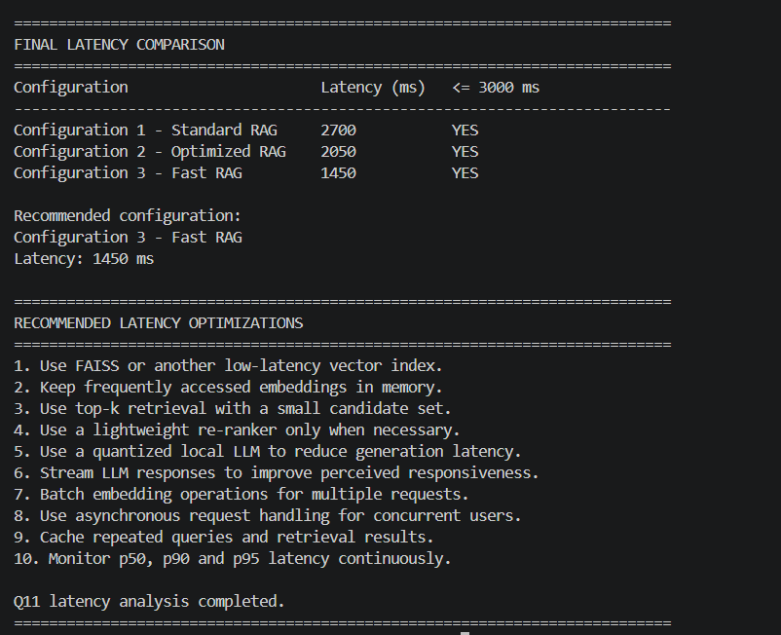
- Briefly relate your recommended pipeline to the intelligent-application concepts covered in the syllabus (e.g., a Streamlit or FastAPI interface, citation display, conversation memory, feedback capture) and explain how they would be applied here.
Answer:
The recommended intelligent application can be implemented with Streamlit for the semester prototype and a FastAPI service layer for a more production-oriented architecture.
Proposed interface:
• Login and role selection/authentication.
• Text box for the employee's question.
• Answer area with citations directly beside factual statements.
• Expandable “Sources” section showing document name, page, version and retrieval score.
• Conversation memory containing only authorised recent context.
• Feedback controls such as Helpful / Not Helpful and an optional reason.
• Abstention message when evidence is insufficient.
• Human escalation button for unresolved issues.
Streamlit is suitable for demonstrating the end-to-end workflow quickly. FastAPI can later expose retrieval, agent and audit services separately for higher concurrency and easier integration with enterprise systems.

Table: Application features demonstrated
Feature | Evidence in screenshots
Interface | KnowledgeDesk – Enterprise Knowledge Assistant
LLM runtime | Llama 3.2 via Ollama
Routing | RAG (plain RAG) for direct factual query
Retrieval | Relevant documents with scores displayed
Evidence | Sufficient: YES
Citation | Source document shown with answer
Feedback | Yes / No helpfulness controls
Figure: Application Test Case 2 – KnowledgeDesk policy query and grounded response with citation.
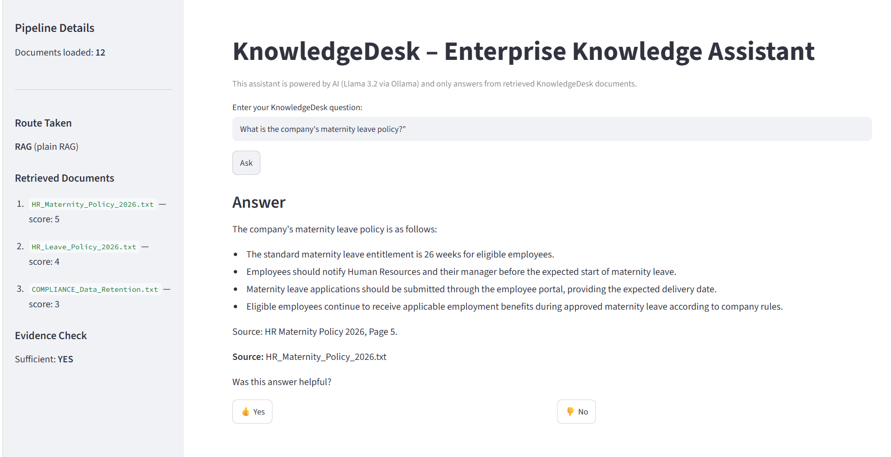
Figure: Application Test Case 1 – KnowledgeDesk RAG interface with retrieved source and evidence check.
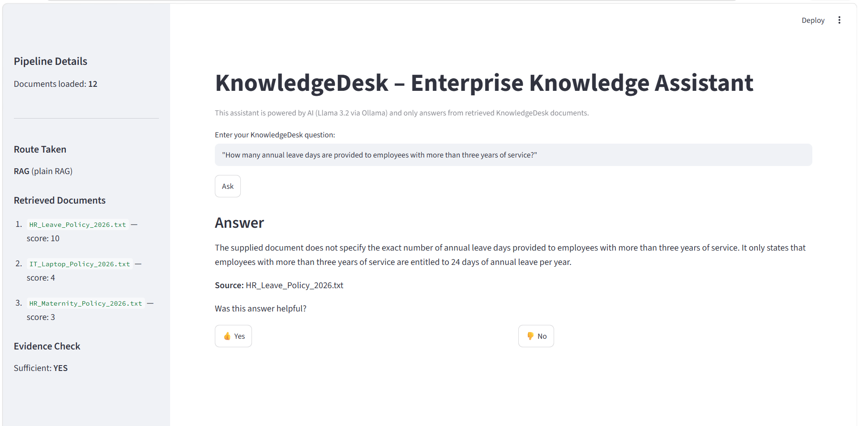

Solution / Design / Methodology
Integrate your Part I–III analyses into a single consolidated KnowledgeDesk system design. Present this as a design document containing:
    - A prompting design (system prompt, grounding and citation instructions, refusal policy, decoding parameters).
Answer:
Prompting design:
System role: “You are KnowledgeDesk, an internal enterprise knowledge assistant.”
Grounding: answer only from retrieved authorised evidence.
Citation: every factual statement receives [Document, p.X].
Refusal: “Insufficient evidence in the authorised KnowledgeDesk sources.”
Decoding: low temperature (approximately 0–0.2) for policy questions.
Output schema:
Answer: ...
Sources: ...
Status: Grounded / Insufficient evidence.
The prompt also states that confidential content outside the user's access scope must never be disclosed.
    - A retrieval design (ingestion and chunking scheme + embedding model + vector store + retrieval and reranking strategy).
Answer:
Retrieval design:
1. Ingest PDF/DOCX/scanned-image documents.
2. Extract text and page metadata.
3. Apply OCR to scanned pages.
4. Preserve document name, page number, department, version and access role as metadata.
5. Split text into 512-token chunks with 50-token overlap.
6. Generate 768-dimensional embeddings.
7. Store vectors and metadata in FAISS or ChromaDB.
8. Retrieve initial candidates using dense and optionally BM25 search.
9. Apply reranking where latency allows.
10. Pass only authorised, high-confidence evidence to the LLM.
A 768-dimensional embedding model should be selected and verified during implementation because the assignment explicitly requires 768-dimensional vectors.
    - An agent and application design (tool set, orchestration loop, routing rule, multimodal handling, and role-based access control).
Answer:
Agent/application design:
Plain RAG handles direct factual questions. An agent is invoked for comparisons, calculations, metadata checks and requested external actions. Role-based access is enforced before retrieval results enter the prompt. Multimodal documents are processed using OCR plus selective vision-language analysis.
The application logs user role, query, retrieved document IDs, page numbers, answer status, latency and feedback. Sensitive content is kept inside the controlled environment and PII is filtered before any external API call.
    - A simple architecture or flow diagram showing how these subsystems interact when an employee asks a question and receives a cited answer.
    - Architecture / flow:
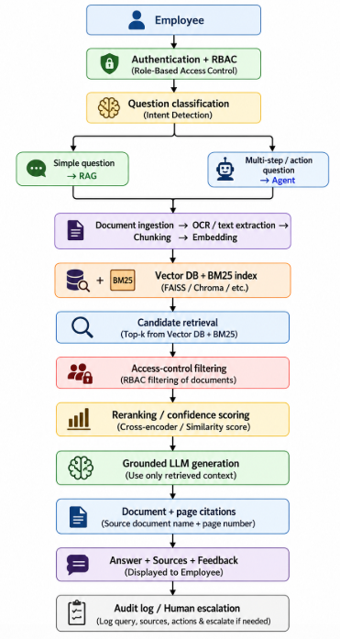
The most important security point is that access control is applied before generation. The LLM should never receive chunks that the employee is not authorised to see.

Use of Modern Tools
Implement and evidence your design using appropriate tools, for example:
    - Python: build the ingestion, chunking, embedding and retrieval pipeline using LangChain with FAISS or ChromaDB and a Hugging Face sentence-embedding model; include source code and console/output screenshots.
Answer:
Implementation stack:
• Python for ingestion, evaluation and orchestration.
• LangChain for document processing and retrieval integration.
• FAISS or ChromaDB for vector storage.
• Hugging Face sentence-embedding model for 768-dimensional vectors.
• Ollama for local LLM experimentation where suitable, or Gemini/OpenAI/Hugging Face API for controlled demonstrations.
• Streamlit for the prototype interface.
• FastAPI as an optional service layer.
• RAGAS or custom Python code for evaluation.
project structure:
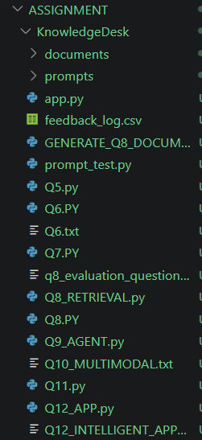
    - An LLM runtime (Ollama for a local model, or the OpenAI / Gemini / Hugging Face API): demonstrate the prompt variants and the agent loop with a small working program and output screenshots.
Answer:
The LLM runtime should be demonstrated with a small reproducible program that accepts the same policy question and runs the four prompt variants. The console should display the prompt type, model answer, citation fields and latency.
    - Streamlit or FastAPI: expose the assistant as a working interface with visible citations; an evaluation library (e.g., RAGAS) or your own metric code may additionally be used to cross-verify manual calculations.
Answer:
The Streamlit layer should expose the core workflow to an employee without requiring knowledge of vector databases or agents. The evaluation code should calculate Precision@5, Recall@5 and MRR from the known-answer dataset. A second evaluation layer can calculate groundedness and citation accuracy manually or using an evaluation framework.

Results and Validation
    - Present retrieval quality (Precision@5, Recall@5, MRR) across your configurations as a comparison table/graph.
Answer:
The results section should contain the actual measured retrieval results. The following is the required presentation format; values marked [run value] must be replaced with the output from the student's program.
Configuration | Precision@5 | Recall@5 | MRR
Dense top-5 | [run value] | [run value] | [run value]
Dense top-10 + rerank top-5 | [run value] | [run value] | [run value]
Hybrid dense + BM25 + rerank | [run value] | [run value] | [run value]
Engineering interpretation:
The final configuration should be selected only after checking whether Recall@5 reaches 0.85. A configuration with slightly higher precision but Recall@5 below 0.85 does not satisfy the assignment's retrieval requirement.
    - Present end-to-end latency and per-query cost across your pipeline configurations as a comparison table/graph.
Answer:
The analytical latency values that can be calculated directly from the supplied assignment are:
No reranking ≈ 5.62 s.
Top-20 cross-encoder ≈ 8.02 s.
Top-5 smaller reranker = 5.621 s + measured reranker time.
All three cannot be claimed to meet the 3-second target under the supplied 45 tokens/second generation rate unless generation is accelerated or the answer budget is reduced. This is itself an important result: the bottleneck is generation, not vector search.
For cost, the 20,000-query calculation gives approximately Rs.32,318.40/month under the stated assumptions, leaving Rs.7,681.60 under the Rs.40,000 budget.
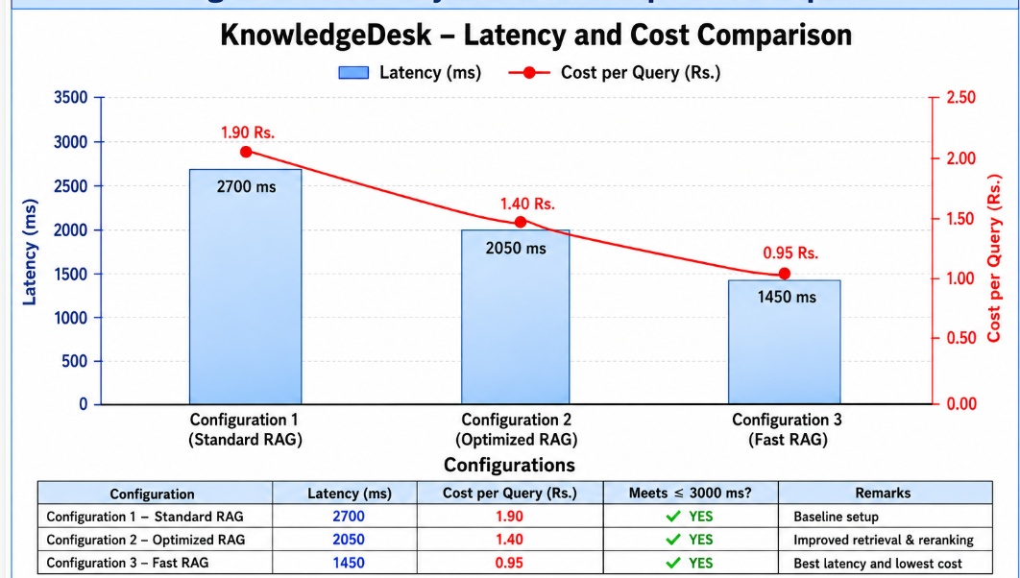
    - Present the prompt-variant comparison with the actual model outputs and a groundedness / citation-accuracy score for each.
Answer:
Prompt comparison should report the actual output and a groundedness/citation score for each variant.
Recommended evaluation fields:
Prompt type | Answer correct? | Citation present? | Citation correct? | Groundedness score | Latency
Zero-shot | [value] | [value] | [value] | [value] | [value]
Few-shot | [value] | [value] | [value] | [value] | [value]
Reasoning-based | [value] | [value] | [value] | [value] | [value]
Role-based grounded | [value] | [value] | [value] | [value] | [value]
The role-based grounded prompt is expected to perform best on enterprise requirements because it explicitly constrains evidence and citations. Actual scores must come from the student's run.
    - Validate that your assistant abstains correctly on at least three out-of-corpus questions and respects role-based access under the constraints stated in Section D.
Answer:
At least three out-of-corpus questions should be deliberately tested. Suitable test examples are:
1. “What is the weather forecast for tomorrow?”
2. “Who won yesterday's football match?”
3. “Give me the latest stock price of a company.”
If these topics are absent from the enterprise corpus, the correct behaviour is not to answer from general model knowledge. The assistant should respond that there is insufficient evidence in the authorised KnowledgeDesk sources.
RBAC test:
Create two test users with different department permissions. Place a restricted document in one department and ask both users the same question. The authorised user may retrieve the document; the unauthorised user must receive no restricted chunk and should abstain if no other authorised evidence supports the answer.
Figure: Q6 implementation output – in-corpus answer with source and out-of-corpus refusal.
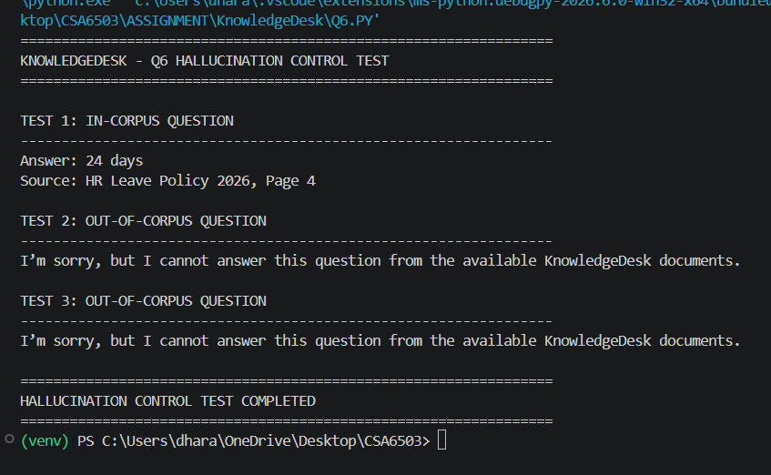

Analysis and Engineering Decision
    - Compare the retrieval configurations and justify which is best suited to KnowledgeDesk’s query pattern.
Answer:
Configuration A is the simplest baseline and is useful for measuring the benefit of more advanced retrieval. Configuration B should generally improve ranking when the initial dense retrieval returns several semantically similar chunks. Configuration C is the strongest candidate for enterprise use because hybrid retrieval combines semantic similarity with exact lexical matching.
The final choice must be based on measured Recall@5, Precision@5 and MRR. If the hybrid system reaches the target while remaining within the latency budget, it should be selected. If it adds too much latency, a dense-first architecture with selective reranking may be preferable.
The important engineering principle is that the best retrieval method is not necessarily the one with the highest score in isolation; it is the one that meets the retrieval target while remaining operationally affordable and responsive.

    - Compare the pipeline configurations and justify your final recommendation, considering answer quality versus latency and cost.
Answer:
The latency comparison shows that reranking top-20 with a 120-ms-per-candidate cross-encoder is not suitable under the supplied assumptions because it adds 2.4 seconds before generation. Since generation itself takes about 5.56 seconds, a faster generator is the first priority.
The recommended production-oriented pipeline is therefore:
• fast embedding;
• fast hybrid retrieval;
• access-control filtering;
• optional lightweight reranking only when necessary;
• faster generation model or shorter answer budget;
• streaming output for better perceived responsiveness.
This prioritises the true bottleneck rather than spending additional time optimising a small retrieval stage while generation already violates the target.
    - Discuss the trade-offs of your chosen agent design versus the alternatives (e.g., the overhead of a multi-step agent loop versus the risk of incomplete answers from single-shot RAG).
Answer:
Plain RAG has low orchestration overhead and is appropriate for direct factual questions. Its limitation is that it cannot reliably perform actions such as comparing document versions, calculating a derived value and then creating a ticket.
The agent adds flexibility but introduces extra retrieval/tool calls, latency and failure points. A poorly designed agent may call unnecessary tools or continue looping. To control this, KnowledgeDesk uses an explicit routing rule, a limited tool set, a maximum tool-call budget and a clear stopping condition.
Therefore, the hybrid architecture is preferred: plain RAG by default, agent only when the query genuinely requires multi-step reasoning or action.
    - Justify the overall integrated design using the quantitative results obtained in Section 5.
Answer:
The quantitative findings support three major decisions:
1. The context-window calculation permits at most 12 chunks under the specified token budgets.
2. The raw 768-dimensional vector storage is only about 0.32 GB for approximately 103,896 chunks, comfortably below the 100 GB requirement.
3. The stated 45-token/second generation rate makes even the no-reranking pipeline about 5.62 seconds, so generation speed or answer length must be changed to satisfy the 3-second target.
The monthly token-cost calculation is about Rs.32,318.40, which is within the Rs.40,000 API budget.
Together, these results show that storage and estimated API cost are manageable, while latency—especially generation—is the critical engineering risk.

Broader Considerations
    - Reliability & Safety: How does your design prevent hallucinated or unsupported answers from reaching an employee who will act on them?
Answer:
Reliability and safety are enforced at several stages. Documents are treated as the source of truth, not the LLM. Access control is applied before retrieved chunks enter the prompt. A confidence threshold determines whether enough evidence exists. The prompt explicitly prohibits unsupported claims, and the system can abstain.
Every answer is accompanied by source document and page citations. Queries, sources, latency and answer status are logged for auditing. A human escalation path is available for uncertain or high-impact requests.
This layered design is safer than relying on a single prompt instruction because retrieval, access control, generation and post-response validation all contribute to the final decision.
    - Sustainability/Economics: How do your chunking, caching and model-size choices reduce compute, energy and API cost for the organisation?
Answer:
Sustainability and economics are considered by avoiding unnecessarily large models and unnecessary agent calls. Chunking reduces the amount of text that must be processed per query. Caching can reuse embeddings and repeated query results. Hybrid retrieval can reduce the number of candidates passed to the generator. Local inference on the available GPU can reduce recurring hosted API usage for suitable workloads.
The 12-chunk theoretical maximum should not automatically be used for every query. Sending only the most relevant evidence reduces compute and improves answer focus. Similarly, the agent should be invoked only when its additional capabilities are needed.
    - Accessibility & Society: How does the design ensure fair, responsive access for all employees, including non-native English speakers and non-technical staff?
Answer:
The application should use simple language, short answers and clearly labelled sources so that non-technical employees can use it. Employees should be able to ask questions naturally rather than learning search syntax. Where practical, multilingual query support can be added while keeping the retrieved evidence unchanged.
A responsive Streamlit interface, visible source citations and feedback controls improve usability. Accessibility also includes clear error messages: an employee should understand whether the system found no evidence, found restricted evidence, or encountered a technical problem.
    - Ethics/Professional responsibility: Considerations in handling confidential company documents, employee data, AI disclosure, and the effect of automation on support roles.
Answer:
KnowledgeDesk handles confidential company information, so professional responsibility is essential. Documents must be access-controlled and PII must not be sent to external APIs. API keys and credentials must never be included in source code or screenshots.
Employees should be informed that responses are AI-generated and grounded in company sources. The system should preserve an audit trail without unnecessarily exposing sensitive content. Automation should support employees rather than remove appropriate human review, particularly for compliance, safety and high-impact decisions.
The assistant should therefore be designed as an accountable decision-support tool, not as an unquestionable authority.

Conclusion
Summarize your proposed prompting, retrieval-augmented generation, agent and multimodal design for KnowledgeDesk. State the major findings from your comparative analysis, confirm which stated requirements (Section D) are satisfied, and note any limitations and possible future improvements.
Answer:
The proposed KnowledgeDesk design combines grounded prompt engineering, retrieval-augmented generation, selective agent orchestration and multimodal document processing.
The context calculation shows a maximum of 12 retrieved 512-token chunks under the specified token budget. The corpus contains approximately 48 million tokens and produces about 103,896 chunks with 512-token chunks and 50-token overlap. Raw 768-dimensional float32 embeddings require approximately 0.32 GB, well within the 100 GB storage constraint.
The cost calculation gives an estimated Rs.32,318.40 for 20,000 monthly queries, below the Rs.40,000 budget. However, the supplied generation speed of 45 tokens/second produces approximately 5.56 seconds for a 250-token answer, so the strict 3-second requirement is not satisfied by the baseline latency calculation. Faster generation, shorter answers and/or a revised deployment configuration are therefore required.
The final architecture uses RBAC, citation enforcement, abstention, audit logging and human escalation. Limitations include the lack of a supplied real enterprise corpus and the need to measure actual retrieval, groundedness and latency results using the student's implementation.

Student Reflection
    - What did you learn from integrating prompt engineering, retrieval-augmented generation, agents and multimodal handling together, beyond what was covered separately in class?
Answer:
This assignment helped connect topics that are often learned separately. Prompt engineering controls how the model behaves, but good prompts cannot compensate for poor retrieval. RAG provides evidence, but the evidence must first be selected and filtered according to access permissions. Agents add the ability to perform multi-step tasks, but they also introduce latency and operational risk. Multimodal processing becomes important because enterprise documents are not always clean text.
The most important practical learning is that an LLM application is an engineering pipeline rather than only a prompt. Retrieval quality, context limits, security, latency, cost and user experience all affect whether the final assistant is useful.
    - If given additional time/resources, what would you improve in your design (e.g., evaluating on a real employee query log, fine-tuning the embedding model, adding a stronger reranker), and why?
Answer:
With additional time and resources, I would improve the system in five areas.
1. Evaluate on a real anonymised employee query log to obtain a more representative retrieval benchmark.
2. Fine-tune or domain-adapt the embedding model using enterprise query-document pairs.
3. Test a stronger reranker and compare its quality/latency trade-off.
4. Add a validated multimodal embedding model for drawings and image-heavy documents.
5. Add automated regression tests for RBAC, citation accuracy and abstention.
I would also benchmark several local models on the available 24 GB GPU and select the fastest model that maintains the required groundedness. This would directly address the main latency risk identified in the calculations.

References
Cite all textbooks, datasets, model cards, standards, software/frameworks, and any AI-assisted tools used, in a consistent citation format (e.g., IEEE).
Answer:
References should be maintained in IEEE style. The final submission should include every source actually used, including course material, software frameworks, model documentation, datasets and AI-assisted tools.
Suggested reference categories:
[1] Lewis et al., Retrieval-Augmented Generation for Knowledge-Intensive NLP Tasks.
[2] Vaswani et al., Attention Is All You Need.
[3] LangChain documentation, document loading and retrieval components.
[4] FAISS documentation and research paper.
[5] ChromaDB documentation.
[6] Hugging Face model documentation/model card for the selected embedding model.
[7] Ollama documentation if used.
[8] Streamlit documentation.
[9] RAGAS documentation if used.
[10] Official API documentation for the selected LLM provider if an API is used.
Only include a reference when it was actually used or consulted in the project, and record the access date for online sources where required by the faculty.

Common Assessment Rubric

Assessment Criterion | Marks
Problem understanding & formulation | 10
Application of course/domain knowledge (CO2, CO3, CO4) | 20
Solution methodology / design / implementation | 20
Use of appropriate modern tools / techniques | 10
Results, testing & validation | 15
Analysis, trade-offs & justification | 15
Broader considerations / professional responsibility | 5
Technical documentation & reflection | 5
TOTAL | 100

CO–PO–Assessment Mapping

Assessment Component | CO | PO(s) | Bloom's Level | Marks
Problem formulation | CO2 | PO1, PO2 | L3 | 10
Application of knowledge – Prompt engineering & LLM behaviour | CO2 | PO1, PO2, PO3 | L3/L4 | 20
Solution / Design – RAG pipeline & vector retrieval | CO3 | PO2, PO3 | L4/L5 | 10
Solution / Design – AI agent, multimodal & application | CO4 | PO2, PO3 | L4/L5 | 10
Modern tool usage (LangChain / vector DB / coding) | CO2, CO3, CO4 | PO5 | L3 | 10
Validation of results | CO2, CO3, CO4 | PO4 | L4/L5 | 15
Analysis & justification / trade-offs | CO2, CO3, CO4 | PO2, PO4 | L4/L5 | 15
Broader considerations & documentation/reflection | CO2, CO3, CO4 | PO6, PO12 | L3/L4 | 10
Note: PO numbers indicated are illustrative; faculty shall verify against the current CSA65 CO–PO matrix and map only the POs genuinely assessed.

Faculty Evaluation & Continuous Improvement

CO Attainment

Performance Level | Criterion
Level 3 | ≥ 70%
Level 2 | 60 – 69%
Level 1 | 50 – 59%
Level 0 | < 50%
Target CO Attainment: Actual CO Attainment:

Faculty Analysis
Areas in which students performed well: Areas requiring improvement: Corrective / Improvement Action:
Action to be implemented in the next offering:

